

NCIA – National Cancer Imaging Archive

Software Design Description

Release 2.0 – QA Tool


Document Change Record
Version Number | Date | Description
1.0 | 06/20/06 | Initial document

TABLE OF CONTENTS
1. Introduction 1
1.1 PROJECT BACKGROUND 1
1.2 SYSTEM OVERVIEW 1
1.3 Requirements Traceability 2
1.3.1 Relevant Statement of Work Tasks 2
2. Use Cases 3
2.1.1 New Use Cases 3
2.1.2 Manage QA Status 3
2.1.3 Change Quality Assurance Status of Images 5
2.1.4 Change Quality Assurance Status of Series 6
2.1.5 Change Quality Assurance Status of Studies 7
2.1.6 Change Quality Assurance Status of a Patients 9
2.1.7 View DICOM Header in Quality Assurance Tool 10
2.1.8 View Full Size JPEG in Quality Assurance Tool 11
2.1.9 View Quality Assurance History for an Image 12
2.1.10 QA Status Report Use Case 12
2.1.11 Changes to Existing Use Cases 13
2.1.12 Parse and Store DICOM File Use Case 13
2.1.13 Display Search Results Use Case 15
2.1.14 Add to Data Basket Use Case 17
2.1.15 Mark Saved Query as Having New Data Available Use Case 17
2.1.16 Manage Access to Collection Data 18
2.1.17 Manage Access to Site Data 19
2.1.18 Manage Access to Series Security Group 20
3. System Architecture 22
4. configuration 23
4.1 CSM Configuration 23
5. Sequence diagrams 24
5.1 Change QA Status 24
5.2 View image and image information 25
6. Components 26
6.1 USER INTERFACE 26
6.1.1 QA Tool Navigation Page 26
6.2 User interface Backing Beans 30
6.2.1 QAToolBean 30
6.3 MIDDLE TIER 30
6.3.1 VisibilityStatusManager 30
6.3.2 QAStatusHistoryManager 31
6.3.3 ImageManager 31
6.3.4 QATreeManager 32
6.4 BACK END 32
6.4.1 Domain Classes 32
6.4.2 Hibernate Mapping Files 35
▪ TrialDataProvenance.hbm.xml 35
▪ Patient.hbm.xml 35
▪ Study.hbm.xml 35
▪ GeneralSeries.hbm.xml 35
▪ GeneralImage.hbm.xml 35
▪ QAStatusHistoryItem.hbm.xml 35
6.4.3 Database Design 35
6.5 Utilities 36
6.5.1 LazyTreeNode 36

Introduction
The purpose of this document is to describe the design for the QA Tool feature being developed for Release 2.0 of the NCIA – National Cancer Imaging Archive software.
The QA Tool is a feature that will be used to change the quality assurance status of an image. Users with sufficient privileges will be able to go into the tool, view the images with different QA Statuses and change those statuses to make images visible, not visible, marked for curation, resend or not yet reviewed. The user will also be able to view the history of these changes for an image as well as the full DICOM header information and the full size DICOM image.

PROJECT BACKGROUND
Please refer to the NCIA Architecture Overview for background on the NCIA project.

SYSTEM OVERVIEW
Please refer to the NCIA Architecture Overview for a system overview.
.

Requirements Traceability

Relevant Statement of Work Tasks
The NCIA Statement of Work (SOW) Task Description contains the following items that will be implemented as part of this design:

4.1.7 Provide a Tool for Image and Annotation Quality Assurance (2.1.1)
This task involves the creation of a secure user interface to allow for selecting an image for quality assurance (QA), indicating the visibility status, and providing auditing and workflow information. Task details are as follows:
▪ Provide support for basic workflow which will allow each item to be set to a curation status throughout the QA process:
o Not Yet Reviewed – default status
o Visible – data is visible in NCIA
o Not Visible – data is unacceptable and will never be visible in NCIA
o Resend – Site will resend after request from QA person
o Send to Curation – Data needs changes prior to being made visible. Or, annotations data needs to be extracted and stored.
▪ Log all changes for auditing purposes
o Auditing consists of tracking the curator name, timestamp, and comments for each image or series curated.
▪ Provide authorized users with data views based on their identified role
▪ Create reports (available through Crystal Reports) to show what percentage of each trial is visible.
▪ Assumptions:
o No DICOM image download through this QA tool
o Third party image viewer integration is not included in this task.

Use Cases
User preferences requirements were documented by a combination of adding new use cases and updating existing use cases.

New Use Cases

Manage QA Status

Use Case Name | Manage QA Status
Use Case ID | 4.1
Primary Actor | QA Reviewer
Trigger | Images and annotations have been submitted and are ready for review by a QA reviewer.
Pre-conditions | - A NCIA image QA Standard Operating Procedure (SOP) for DICOM images has been developed in collaboration with the Cancer Imaging Program (CIP) and approved by National Cancer Institute Center for Bioinformatics (NCICB) and CIP.  - Images have been submitted to NCIA (see use case 1.1 or 1.2)  - QA Reviewer has logged into NCIA (see use case 8.2).  - QA Reviewer has been granted the MANAGE_VISIBILITY_STATUS privilege in the CSM for at least one protection element representing a collection, site or series security group.
Flow of Events | - QA Reviewer navigates to Manage QA Status page.  - QA Reviewer is presented with a list of all QA statuses  - QA Reviewer clicks on a status  - QA Reviewer is presented with a list of all collections that have images in that status. The list does not include collections that the QA Reviewer does not have access to. Collections where at least one of its images has had its status changed during this user session are highlighted.  - QA Reviewer clicks on a collection  - QA Reviewer is presented with a list of all patients in the collection that have images in the status selected earlier. Images that are part of sites or series security groups that the QA Reviewer does not have the MANAGE_VISIBILITY_STATUS privilege for are not considered when creating the list of patients. Patients where at least one of its images has had its status changed during this user session are highlighted.  - QA Reviewer has the option to change the QA status of images for one or more patients (see use case 4.5) in the collection.  - QA Reviewer clicks on a patient  - QA Reviewer is presented with a list of all studies for the patient that have images in the status selected earlier. Images that are part of sites or series security groups that the QA Reviewer does not have MANAGE_VISIBILITY_STATUS privilege for are not considered when creating the list of studies. Studies where at least one of its images has had its status changed during this user session are highlighted.  - QA Reviewer has the option to change the QA status of images for one or more studies (see use case 4.4) for the patient.  - QA Reviewer clicks on a study  - QA Reviewer is presented with a list of all series for the study that have images in the status selected earlier. Images that are part of sites or series security groups that the QA Reviewer does not have the MANAGE_VISIBILITY_STATUS privilege for are not considered when creating the list of studies. Series where at least one of its images has had its status changed during this user session are highlighted.  - QA Reviewer has the option to change the QA status of images for one or more series (see use case 4.3) in the study.  - QA Reviewer clicks on a series under the study selected previously.  - QA Reviewer is presented with a list of annotation files for the series and a thumbnail for each image in the series.  - For one or more images, the QA Reviewer has the option to change the QA status (see use case 4.2)  - For each image, the QA Reviewer has the option to:  - View a JPEG of the image (see use case 4.11)  - View the history for the image (see use case 4.12)
Post-Conditions
Alternative Flow | - QA Reviewer has not been granted the MANAGE_VISIBILITY_STATUS privilege in the CSM for any protection elements representing a collection, site or series security group. The link to the Manage Visibility Status page does not appear.  - User is viewing data that has the “Not Yet Reviewed” QA status. For that status, no highlighting occurs.
Related Use Cases | - 4.2 - Change Quality Assurance Status of Images  - 4.3 - Change Quality Assurance Status of Series  - 4.4 - Change Quality Assurance Status of Studies  - 4.5 - Change Quality Assurance Status of Patients  - 4.9 - View DICOM Header in Quality Assurance Tool  - 4.11 - View Full Size JPEG in Quality Assurance Tool  - 4.12 - View Quality Assurance HIstory for an Image

Change Quality Assurance Status of Images

Use Case Name | Change Quality Assurance Status of Images
Use Case ID | 4.2
Primary Actor | QA Reviewer
Trigger | QA Reviewer wants to change the QA status of an image.
Pre-conditions | - In the QA tool, QA Reviewer has navigated to view the data for a series (see use case 4.1). The QA tool displays a list of annotation files and the image thumbnails for all images in a series.  - QA reviewer has the MANAGE_VISIBILITY_STATUS privilege for the collection, site, and series security group to which the series belongs.
Flow of Events | - QA Reviewer selects one or more images  - QA Reviewer selects the new status from a list of available QA statuses:  - Not Yet Reviewed  - Visible  - Not Visible  - Resend  - Send to Curation  - If QA Reviewer wants to enter a comment about the image, they enter it in the field provided.  - QA Reviewer presses the “Change Status” button.
Post-Conditions | QA Status of the selected image(s) is changed to the status selected. A Curation Status record is added to the database that includes associations to each image, the user that made the change and any comment provided.  System verifies that the visibility flags of the each image’s series, study and patient are correct. The visibility flag at each level is set to true if at least one image under that item is set to a QA status of Visible.  User is presented with a message indicating that the change was successful: “Status changed to {0}” where {0} represents the new status.
Alternative Flow | - During the time period starting when the user loaded data for the image and ending when the user made the status change, another user has made a QA status change for the same image. Status change is not saved and user receives the following error message: “Could not change status of the image because another user has made a status change to the same image.”
Related Use Cases | 4.1 – Manage QA Status

Change Quality Assurance Status of Series

Use Case Name | Change Quality Assurance Status of Series
Use Case ID | 4.3
Primary Actor | QA Reviewer
Trigger | QA Reviewer wants to change the QA status of all images and annotation files in one or more series.
Pre-conditions | - In the QA tool, QA Reviewer has navigated to view the data for a study (see use case 4.1). The QA tool displays a list of series in the study.  - QA reviewer has the MANAGE_VISIBILITY_STATUS privilege for the collection, site, and series security group to which the series belongs.
Flow of Events | - QA Reviewer selects one or more series  - QA Reviewer selects the new status from a list of available QA statuses:  - Not Yet Reviewed  - Visible  - Not Visible  - Resend  - Send to Curation  - If QA Reviewer wants to enter a comment, they enter it in the field provided.  - If QA Reviewer wants to assign the series to a series security group, they enter it in the field provided.  - QA Reviewer presses the “Change Status” button.
Post-Conditions | System determines the QA status from which the user navigated to get to the study. Images in the selected series with that status to which the user has access (MANAGE_VISBILITY_STATUS privilege) are changed to the newly selected status.  For each image, a Curation Status record is added to the database that includes associations to the image, the user that made the change and any comment provided. For each series, the series is assigned to the series security group (if provided).  System verifies that the visibility flags of the series, its study and its patient are correct. The visibility flag at each level is set to true if at least one image under that item is set to a QA status of Visible.  User is presented with a message indicating that the change was successful: “Status changed to {0}” where {0} represents the new status.
Alternative Flow | During the time period starting when the user loaded data for the image and ending when the user made the status change, another user has made a QA status change for the same image. Status change for that image is not saved and user receives the following error message: “Could not change status of the image with SOP instance UID {0} because another user has made a status change to the same image.” where {0} represents the SOP instance UID of the image.
Related Use Cases | 4.1 – Manage QA Status

Change Quality Assurance Status of Studies

Use Case Name | Change Quality Assurance Status of Studies
Use Case ID | 4.4
Primary Actor | QA Reviewer
Trigger | QA Reviewer wants to change the QA status of all images and annotation files in one or more studies.
Pre-conditions | - In the QA tool, QA Reviewer has navigated to view the data for a patient (see use case 4.1).  - QA reviewer has the MANAGE_VISIBILITY_STATUS privilege for the collection, site, and series security group to which at least one series of the study belongs.
Flow of Events | - QA Reviewer selects one or more studies.  - QA Reviewer selects the new status from a list of available QA statuses:  - Not Yet Reviewed  - Visible  - Not Visible  - Resend  - Send to Curation  - If QA Reviewer wants to enter a comment, they enter it in the field provided.  - If QA Reviewer wants to assign the study’s series to a series security group, they enter it in the field provided.  - QA Reviewer presses the “Change Status” button.
Post-Conditions | System determines the QA status from which the user navigated to get to the patient. Images in the selected studies with that status to which the user has access (MANAGE_VISBILITY_STATUS privilege) are changed to the newly selected status.  For each image, a Curation Status record is added to the database that includes associations to the image, the user that made the change and any comment provided. For each series, the series is assigned to the series security group (if provided).  System verifies that the visibility flags of the study, the study’s patient and all child series are correct. The visibility flag at each level is set to true if at least one image under that item is set to a QA status of Visible.  User is presented with a message indicating that the change was successful: “Status changed to {0}” where {0} represents the new status.
Alternative Flow | During the time period starting when the user loaded data for the image and ending when the user made the status change, another user has made a QA status change for the same image. Status change for that image is not saved and user receives the following error message: “Could not change status of the image with SOP instance UID {0} because another user has made a status change to the same image.” where {0} represents the SOP instance UID of the image.
Related Use Cases | 4.1 – Manage QA Status

Change Quality Assurance Status of a Patients

Use Case Name | Change Quality Assurance Status of a Patients
Use Case ID | 4.5
Primary Actor | QA Reviewer
Trigger | QA Reviewer wants to change the QA status of all images and annotation files in a study.
Pre-conditions | - In the QA tool, QA Reviewer has navigated to view the data for a collection (see use case 4.1).  - QA reviewer has the MANAGE_VISIBILITY_STATUS privilege for the collection, site, and series security group to which at least one series for the patient belongs.
Flow of Events | - QA Reviewer selects one or more patients.  - QA Reviewer selects the new status from a list of available QA statuses:  - Not Yet Reviewed  - Visible  - Not Visible  - Resend  - Send to Curation  - If QA Reviewer wants to enter a comment, they enter it in the field provided.  - If QA Reviewer wants to assign the patient’s series to a series security group, they enter it in the field provided.  - QA Reviewer presses the “Change Status” button.
Post-Conditions | System determines the QA status from which the user navigated to get to the collection. Images for the selected patients with that status to which the user has access (MANAGE_VISBILITY_STATUS privilege) are changed to the newly selected status.  For each image, a Curation Status record is added to the database that includes associations to the image, the user that made the change and any comment provided. For each series, the series is assigned to the series security group (if provided).  System verifies that the visibility flags of the patient, the child studies, and all child series are correct. The visibility flag at each level is set to true if at least one image under that item is set to a QA status of Visible.  User is presented with a message indicating that the change was successful: “Status changed to {0}” where {0} represents the new status.
Alternative Flow | During the time period starting when the user loaded data for the image and ending when the user made the status change, another user has made a QA status change to the same image. Status change for that image is not saved and user receives the following error message: “Could not change status of the image with SOP instance UID {0} because another user has made a status change to the same image.” where {0} represents the SOP instance UID of the image.
Related Use Cases | 4.1 – Manage QA Status

View DICOM Header in Quality Assurance Tool

Use Case Name | View DICOM Header in Quality Assurance Tool
Use Case ID | 4.9
Primary Actor | QA Reviewer
Trigger | QA Reviewer wants to review an image’s DICOM header.
Pre-conditions | - In the QA tool, QA Reviewer has navigated to view the data for a series (see use case 4.1). The QA tool displays the image thumbnails for all images in a series.  - QA reviewer has the MANAGE_VISIBILITY_STATUS privilege for the collection, site, and series security group to which the image belongs.
Flow of Events | - QA Reviewer clicks the “View DICOM Header” link for an image thumbnail.  - A new browser window opens that shows all non-empty DICOM tags in the image’s DICOM header.  - QA Reviewer examines the DICOM header values to determine if the image and its data pass the standards established in the SOP.  - QA Reviewer closes the second browser window.
Post-Conditions
Alternative Flow | - A browser window showing the DICOM header for another image is already open. Instead of opening a new window, the QA tool displays the DICOM header in the already open window.
Related Use Cases | 4.1 – Manage QA Status

View Full Size JPEG in Quality Assurance Tool

Use Case Name | View Full Size JPEG in Quality Assurance Tool
Use Case ID | 4.11
Primary Actor | QA Reviewer
Trigger | QA Reviewer wants to review a JPEG of a DICOM image without having to download the file and open it in a viewing tool.
Pre-conditions | - In the QA tool, QA Reviewer has navigated to view the data for a series (see use case 4.1). The QA tool displays the image thumbnails for all images in a series.  - QA reviewer has the MANAGE_VISIBILITY_STATUS privilege for the collection, site, and series security group to which the image belongs.
Flow of Events | - QA Reviewer clicks the “View JPEG” link for an image thumbnail.  - A new browser window opens that displays a JPEG of the DICOM image.  - QA Reviewer examines the JPEG to determine if the image and its data pass the standards established in the SOP.  - QA Reviewer closes the second browser window.
Post-Conditions
Alternative Flow | - A browser window showing the JPEG for another image is already open. Instead of opening a new window, the QA tool displays the JPEG in the already open window.
Related Use Cases | 4.1 – Manage QA Status

View Quality Assurance History for an Image

Use Case Name | View Quality Assurance History for an Image
Use Case ID | 4.12
Primary Actor | QA Reviewer
Trigger | QA Reviewer wants to view the actions that have taken place related to QA for an image.
Pre-conditions | - In the QA tool, QA Reviewer has navigated to view the data for a series (see use case 4.1). The QA tool displays the image thumbnails for all images in a series.  - QA reviewer has the MANAGE_VISIBILITY_STATUS privilege for the collection, site, and series security group to which the image belongs.
Flow of Events | - QA Reviewer clicks the “Show History” link for an image thumbnail.  - The history related to QA is displayed for this image. The history includes the following:  - Date of submission  - Dates of all status changes and what the status was changed to  - Comments provided by QA Reviewer when status was changed  - QA Reviewer clicks the “Hide History” link.  - History is no longer displayed.
Post-Conditions
Alternative Flow
Related Use Cases | 4.1 – Manage QA Status

QA Status Report Use Case

Use Case Name | QA Status Report
Use Case ID | 14.6
Primary Actor | User
Trigger | Administrator wants to monitor the progress of the QA process.
Pre-conditions | - User has access to external reporting tool.  - QA Status report has been created using external reporting tool.
Flow of Events | 1. User logs into external reporting tool and chooses to view the QA Status Report.  2. A report is displayed that consists of a list of collections. For each collection, the report shows the number of images that are in each QA status (e.g. Visible, Not Visible).
Post-Conditions
Alternative Flow
Related Use Case

Changes to Existing Use Cases
The changes relevant to this enhancement are highlighted in green.

Parse and Store DICOM File Use Case

Use Case Name | Parse and Store DICOM File
Use Case ID | 1.3
Primary Actor | NCI MIRC
Trigger | See use case 1.1.
Pre-conditions | - DICOM image has been received by the NCI MIRC.  - Annotations associated with the DICOM file and the DICOM file were sent and anonymized by the same field center.
Flow of Events | - The DICOM parser reads the DICOM file.  - The parser parses the header information based on a property file set by the administrator.  - Data provenance information is extracted from the DICOM header.  - The parser stores selected DICOM header information and the data provenance information in the database. If the subject, study, or series for this image does not exist yet, it will be created.  - If this image is the first image for its series, check to determine if there are any annotations for the series. If there are, set the annotation flag for the series to true and set the annotation records to point to the series.  - The location of the image is stored in the database.  - QA Status for the image is set to Not Yet Reviewed in the database.  - The DICOM file is anonymized to remove data as specified by the curation process (e.g. data provenance information).  - The anonymized DICOM file is saved to the file system. The directory structure used contains subdirectories for the trial, subject, study, and series.
Post-Conditions | Success Condition: Image is stored in file system. Data for the image is stored in database.  Error Condition: The DICOM parser fails to parse the DICOM file
Alternative Flow | - The DICOM parser fails to parse the DICOM image.  - The DICOM file is stored to a quarantine folder for later processing and submission.  - The administrator at the field center site resends the files to NCI MIRC.  - If the DICOM file is submitted via a DVD at a local field center, the administrator at the local field center can resend the file to NCI MIRC.  - NCI MIRC software will update the MIRC document and the database.  - Trial data provenance data is not included in the DICOM header.  - System determines whether the image has already been submitted. This will be true when there is an image in the database that matches the following fields in the header:  - Image SOP Instance UID  - Series Instance UID  - Study Instance UID  - Patient ID  - If the image has been previously submitted, the existing image data is updated with the data from the newly submitted image.  - If the image has not been previously submitted, it will be placed in quarantine because the trial data provenance information was not provided.
Related Use Case | 1.1 Receive DICOM File

Display Search Results Use Case

Use Case Name | Display Search Results Use Case
Use Case ID | 10.1
Primary Actor | Researcher (via Simple/Advanced Search)
Secondary Actor | Image data store  Annotation Database
Trigger | System has successfully retrieved the user requested data for display
Pre-conditions | - The query is executed without any system errors.
Flow of Events | - The system has successfully retrieved the data requested by the user.  - The search results page includes a list of subjects sorted by Subject ID that have at least one visible series matching the criteria. For each subject, the results include:  - Subject ID  - Trial ID  - The number of studies and series for the patient that contain at least one visible image meeting the criteria.  - The total number of studies and series for the patient.  - A “Show Studies” link.  - The actor can click on the Show Studies link to “drill down” to the study level.  - The Search Results (Studies for Subject) page is displayed. It includes a list of all of the studies or the selected subject (sorted by study date) that contain at least one visible series matching the criteria. For each study, the following is displayed:  - Study ID  - Study Description  - Study Date  For each study, a list of series (ordered by series number) for the study that have been marked as visible matching the criteria is displayed. For each series, the following is displayed:  - Series ID  - Total Number of Images in the Series  - Note: This number includes both visible images that meet the criteria and those that don’t.  - Series Description  - Series Modality  - Series Equipment Manufacturer  - Whether or not annotations exist for the series. If curation data exists to describe the content type of the series’ annotation files, display all available content types.  - A “Show Images” Link  - The user clicks the “Show images” link to display the visible images in that series.  - The system displays a set of thumbnails for all the images in the series with a QA status of Visible sorted by the image date. (Thumbnails for visible images that do not match the criteria are displayed also). A summary of the series is also displayed that includes whether or not the user has annotations and the content types of the annotation files if there is available curation data to describe the content type.
Post-Conditions | Success Condition: User views the results.
Alternative Flow | - If no data is returned by executing the query, an appropriate message is returned to the search results page.  - On the subject's page, the user clicks on the icon in a column title to sort the list by the data in that column.  - User clicks a link to go back and view the search page. System executes use case 9.1. This option is not available if the search results were created by linking from another application (see use case 9.3).
Related Use Case | 11.4 Add to Data Basket Use Case

Add to Data Basket Use Case

Use Case Name | Add to Data Basket Use Case
Use Case ID | 11.4
Primary Actor | Researcher
Trigger | User clicks on checkboxes at the patient level, study level, series level or image thumbnail level to indicate intention to download images
Pre-conditions | A query has been executed and the user is viewing the results.
Flow of Events | - The user can choose to download all the images at the subject level by clicking on the checkbox next to each subject and clicking on the “Add to Basket” button. When a user chooses to download a subject, the system finds all of the subject’s series that match the criteria. Then, it adds all images with a QA status of Visible in those series (whether they match the criteria or not) to the data basket.  - The user can also “drill down” into each study by clicking on the “Show Studies” link.  - Here they can choose to download all the images at the series level or for a particular study by clicking on the appropriate checkbox and then clicking on the “Add to Basket” button. When a user chooses to download a series, the system adds all visible images in the series (whether they match the criteria or not) to the data basket.  - The user can also click on the “Show Images” link to show all the thumbnail images for a particular series. The user can then “cherry pick” the images they want to download by clicking on the checkbox next to the thumbnail and clicking on the “Add to Basket” button.
Post-Conditions | Success Condition: All the images or set of images are placed in the data basket that can then be managed using the Manage Data Basket Use Case (use case 11.5).
Alternative Flow
Related Use Case

Mark Saved Query as Having New Data Available Use Case

Use Case Name | Mark Saved Query as Having New Data Available
Use Case ID | 12.7
Primary Actor | NCIA Application Batch Process
Trigger | The batch scheduler has been configured to run the Update New Data Flag process at this time.
Pre-conditions | Queries have been saved.
Flow of Events | Loop through each saved query that is not marked as having new data.  Execute the saved query with two modifications:  - Add a filter to only return results that have a curation status date that is greater than the last execute date of the saved query.  - Only return a count instead of the full results.  If the count is greater than zero, mark the query as having new data. If not, skip to the next saved query.
Post-Conditions | Success Condition: Saved queries with new data have their new data flag set to true.
Alternative Flow
Related Use Case | 12.3 - New Data for Saved Query  4.1 - Curate DICOM Images/Annotation

Manage Access to Collection Data

Use Case Name | Manage Access to Collection Data
Use Case ID | 15.2
Primary Actor | Admin User
Trigger | Access needs to be granted or removed for a particular collection’s data.
Pre-conditions | - NCIA has been registered as an application in the CSM User Provisioning Tool (UPT).  - A protection element for the collection has been created.  - Admin User has been granted access to the CSM by the Super Admin User.
Flow of Events | - Admin User logs in to the CSM UPT application for NCIA.  - Admin User goes to the User Home Page.  - Admin User clicks Select an Existing User to find the user that is being granted access.  - Admin User grants the user the READ privilege for the protection element representing the collection.  - If the user also needs permission to manage curation data for the collection, the Admin User will grant the user the CURATE privilege for the protection element representing the collection.  - If the user also needs permission to manage the visibility status of the collection, the Admin User will grant the user the MANAGE_VISBILITY_STAUS privilege for the protection element representing the collection.
Post-Conditions | User is able to view data for the collection.
Alternative Flow | - User needs to have access to a collection removed. Admin User finds the user in UPT then removes the READ privilege for the collection’s protection element.  - A decision has been made to grant all users the ability to view a collection’s data. The protection element is placed in the public group, making it accessible to all users.
Related Use Case

Manage Access to Site Data

Use Case Name | Manage Access to Site Data
Use Case ID | 15.3
Primary Actor | Admin User
Trigger | Access needs to be granted or removed for a particular site’s data.
Pre-conditions | - NCIA has been registered as an application in the CSM User Provisioning Tool (UPT).  - A protection element for the site has been created.  - Admin User has been granted access to the CSM by the Super Admin User.
Flow of Events | - Admin User logs in to the CSM UPT application for NCIA.  - Admin User goes to the User Home Page  - Admin User clicks Select an Existing User to find the user that is being granted access  - Admin User grants the user the READ privilege for the protection element representing the site.  - If the user also needs permission to view the Submission Report for the site, the Admin User will grant the user the VIEW_SUBMISSION_REPORT privilege for the protection element representing the site.  - If the user also needs permission to manage curation data for the site, the Admin User will grant the user the CURATE privilege for the protection element representing the site.  - If the user also needs permission to manage the visibility status of the site, the Admin User will grant the user the MANAGE_VISBILITY_STATUS privilege for the protection element representing the site.
Post-Conditions | User is able to view data for the site.
Alternative Flow | - User needs to have access to a site removed. Admin User finds the user in UPT then removes the READ privilege for the site’s protection element.  - A decision has been made to grant all users the ability to view a site’s data. The protection element is placed in the public group, making it accessible to all users.
Related Use Case | Admin User

Manage Access to Series Security Group

Use Case Name | Manage Access to Series Security Group
Use Case ID | 15.5
Primary Actor | Admin User
Trigger | Access needs to be granted or removed for a particular series security group.
Pre-conditions | - NCIA has been registered as an application in the CSM User Provisioning Tool (UPT).  - A protection element for the series security group has been created.  - Admin User has been granted access to the CSM by the Super Admin User.
Flow of Events | - Admin User logs in to the CSM UPT application for NCIA.  - Admin User goes to the User Home Page.  - Admin User clicks Select an Existing User to find the user that is being granted access.  - Admin User grants the user the READ privilege for the protection element representing the series security group.  - If the user also needs permission to manage curation data for the series in the series security group, the Admin User will grant the user the CURATE privilege for the protection element representing the series security group.  - If the user also needs permission to manage the visibility status of the series in the series security group, the Admin User will grant the user the MANAGE_VISBILITY_STATUS privilege for the protection element representing the series security group.
Post-Conditions | User is able to view data for the site.
Alternative Flow | - User needs to have access to a series security group removed. Admin User finds the user in UPT then removes the READ privilege for the site’s protection element.  - A decision has been made to grant all users the ability to view a series security group data. The protection element is placed in the public group, making it accessible to all users.
Related Use Case | Admin User

System Architecture
No architecture changes are necessary for this enhancement.

configuration

CSM Configuration
Admin user will access UPT tool to create new role for submitter and grant MANAGE_VISIBILITY_STATUS access to QA Reviewer for the protection element representing the collection, site or series.

Quartz Task Scheduling
The open source Quartz framework will be used to schedule to updates to the NewDataFlag for saved queries once per day. The JAR file containing the quartz classes will be added to the WEB-INF/lib directory.

ncia.properties
Two properties will be added to ncia.properties to support scheduling of tasks. The first, runNewDataFlagUpdate, will be set to either ‘true’ or ‘false’. If set to ‘true’, a task will be scheduled to update the new data flag. The purpose of this property is to allow for situations were multiple instances of NCIA are running and where only one of those instances will need to update the new data flag.
The second property, hourToRunNewDataFlagUpdate, will be set to the hour in which the new data flag will be updated (provided runNewDataFlagUpdate is set to true).

WEB.XML
web.xml must be changed to support to addition of a new servlet (see section 6.5.3) and the removal of an existing servlet (see section 6.5.4).

QA Status Report
A report of the number of visible and not yet reviewed images will be added to the crystal reports server.

Sequence diagrams
For some use cases, sequence diagrams are helpful to illustrate the execution flow. Sequence diagrams are included this section for the appropriate use cases. Details of the objects that participate in the use cases are described in section 6.

Change QA Status
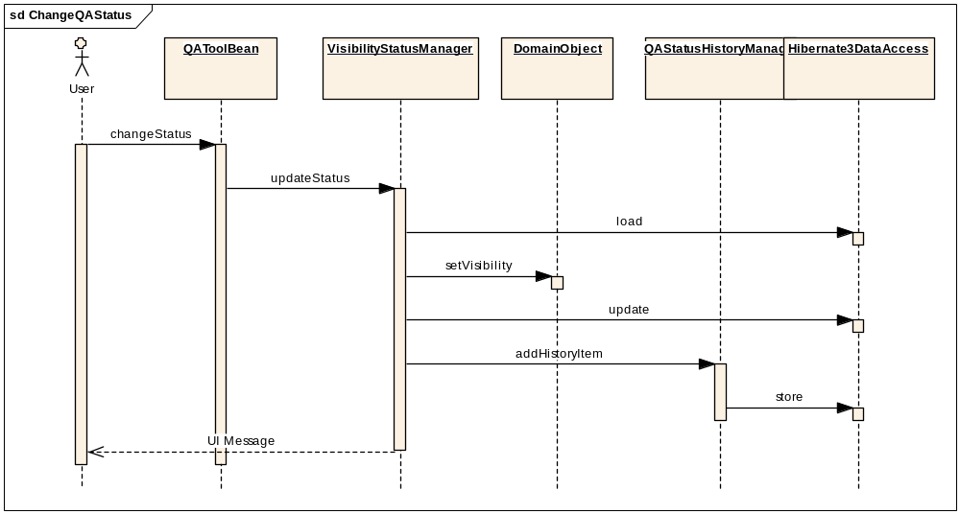

View image and image information
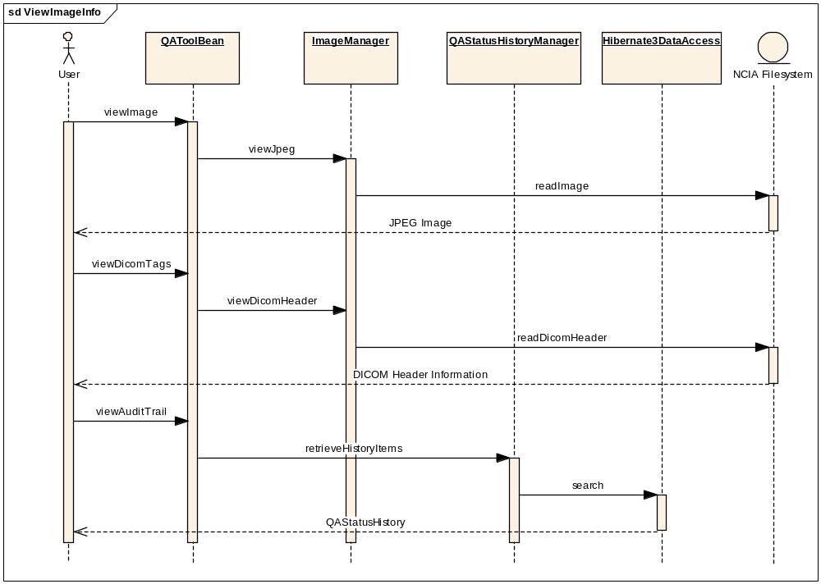

Components

USER INTERFACE

QA Tool Navigation Page
There will be a new link on the left hand navigation bar that will appear for users that have the MANAGE_VISIBILITY_STATUS privilege for at least one protection element.

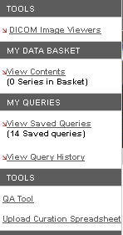

QA Tool
On the QA Tool page, the side submenu will be removed and be replaced with a tree structure that will allow the user to navigate through the different visibility statuses, trials, patients, studies and series. When a user clicks on a node in the tree, relevant information to that item will be displayed in the main section of the page.
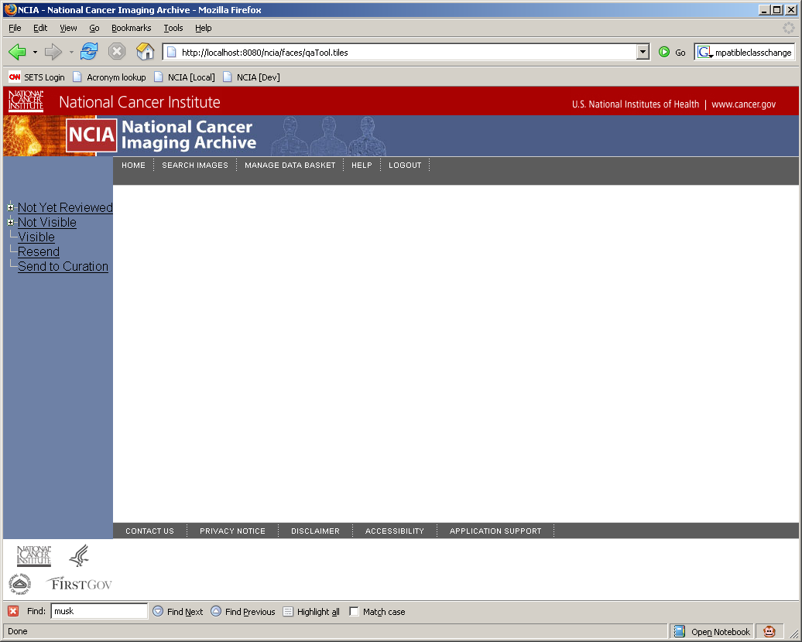
In the main section of the page is where the user will be able to perform the actions that allow them to change the visibility status of that item.
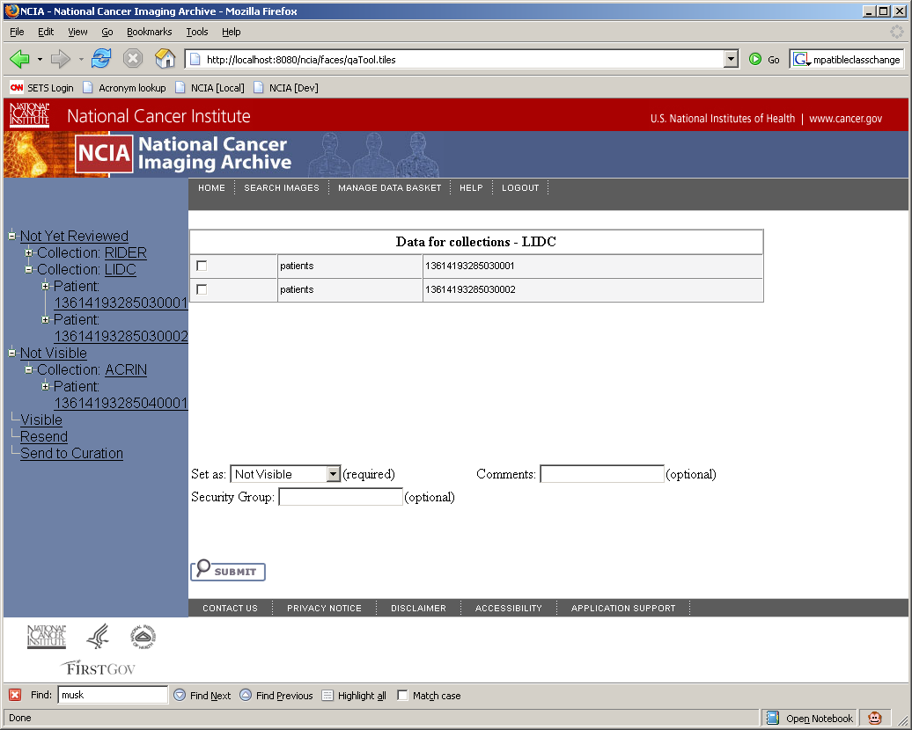

When a user clicks on a series, a page with all of the images will be displayed. On this page, a user will be able to view the full sized jpeg image, which will open in another window.
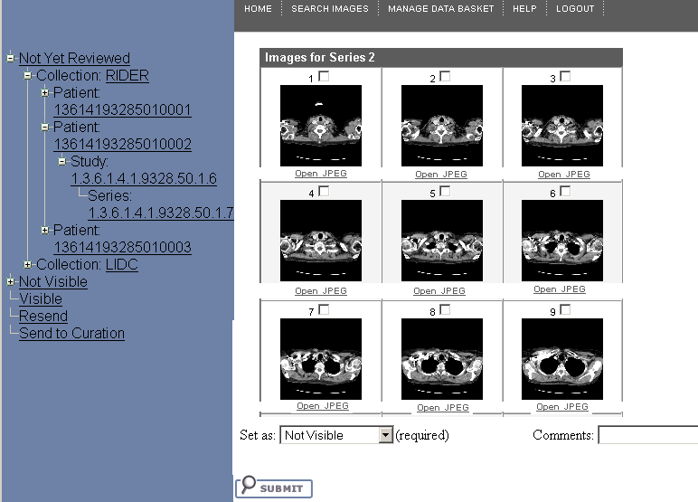

DICOM Header Page
They will also be able to view the DICOM header information, which will also open in another window. In that window, the information will be displayed in a table that looks similar to the DICOM information page displayed by MIRC:

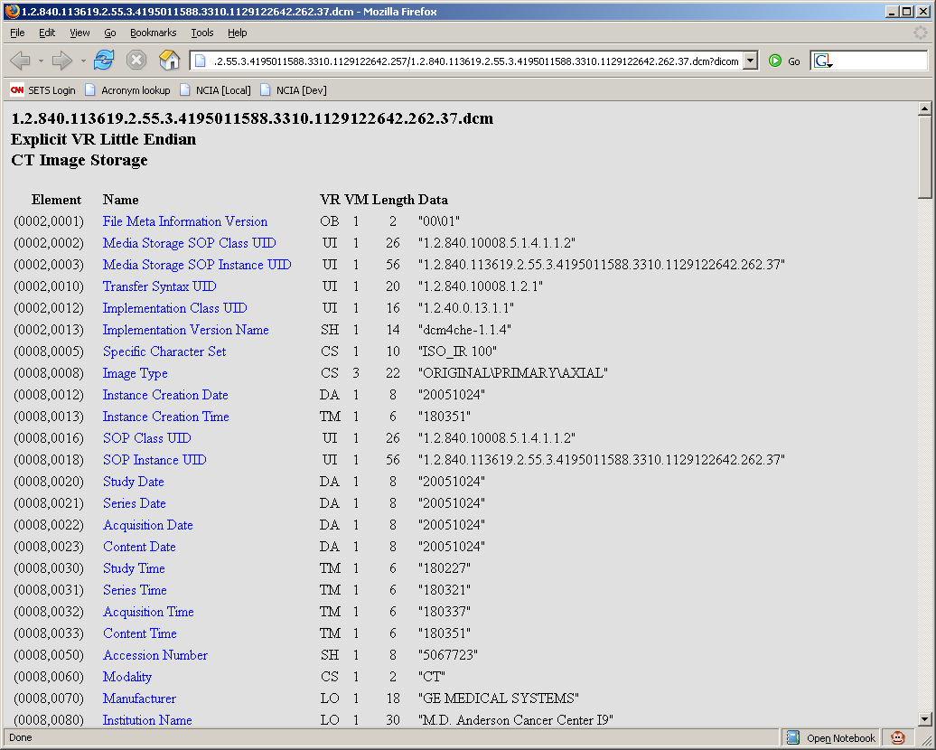

QA Status Page
Also on the image page, a user will be able to view the audit trail of the image and see who has made the changes to the visibility status, as well as when they were made. When the click on the View QA Status History link, a new page will open up, displaying a table similar to this:

Date | User | Comment | Old Value | New Value
7/6/2006 7:15 AM | John Doe | Make Visible | Not Yet Reviewed | Visible

User interface Backing Beans

QAToolBean
The QAToolBean is the backing bean that is responsible for holding all of the data that is relevant to the QA Tool on the JSF side.
New Method Name | Description
viewImage | Will open the full size JPEG image in a new window by calling the ImageManager
viewDicomTags | Will open a new window with all of the DICOM header information by calling the ImageManager
viewQaStatusHistory | Will display the audit trail history on the current page by calling the QAStatusHistoryManager
displaySelectedNode | Will display the node that has been selected on the page and display its children in the main content area.
changeStatus | Will change the visibility status of the selected items to the desired visibility status. When the status is successfully changed, it will display a message on the UI saying “Status changed to {0}” with {0} representing the status that it has been changed to.

New Attribute Name | Attribute Type | Description
qaTree | TreeModelBase | This is the tree representation of all of the images so that the QA Reviewer can navigate the data.

MIDDLE TIER

VisibilityStatusManager
The VisibilityStatusManager will be the class that actually changes the visibility status of an item by using Hibernate3DataAccess. It uses optimistic locking in Hibernate to make sure that another user has not changed the status of an image since it was initially loaded.

New Method Name | Description
changeStatus | This method will take in a domain object and an integer representing the status that the object should be changed to. It will attempt to change the visibility of that object. If the object has already been changed, Hibernate should throw a StaleObjectStateException. It will catch this exception and pass it up to the user interface, with the message: “Could not change status of the image because another user has made a status change to the same image.” Once the status has been changed on the image, it will be highlighted in the tree, and all of the levels above the changed image will also be highlighted. When an image is changed to QA status “visible”, the curationTimestamp will be updated.

QAStatusHistoryManager

New Method Name | Description
addHistoryItem | This method will add a QAStatusHistoryItem for an image. It will take in a GeneralImage PK ID, an old QA Status, a new QA Status and a comment. It will then create a record for that particular GeneralImage.
retrieveHistoryItems | This will take in a GerneralImage PK ID as a parameter and return a list of QAStatusHistoryItems for that image to be displayed on the UI.

ImageManager
The ImageManager will perform all of the reading of image files and DICOM files from the file system. It will allow the user to view the full size JPEG image and also the DICOM header info.
New Method Name | Description
registerFilePath | Adds a file path and ID to the hash map so that it can be looked up by the ImageServlet later.
lookupRegisteredPath | This method is going to be moved from SecurityBean to ImageManager so that ImageManager will be responsible for securing the images and mapping the Ids to the paths.
viewDicomHeader | Takes in an ID from the registered Ids and then will return a hash map of key value pairs representing the DICOM header information where the key is the tag number and the value is the actual value for the image. Will open the DICOM image from the file system and parse it using dcm4che library.

QATreeManager

This class will look up the values for the navigation tree for the QA tool.
New Method Name | Description
getChildren | This will take in a String representing an identifier of a node and return a list of strings that are the identifiers of the children nodes for that node so that the children nodes can be built. It will use Hibernate3DataAccess to retrieve the domain objects with the correct visibilities. It will make sure that the user has the MANAGE_VISIBILITY_STATUS privilege for the protection elements in question.

BACK END

Domain Classes
All of the domain objects except for QAStatusHistoryItem are being created as part of the QA Tool enhancement. This enhancement requires for these classes to be modified however.

QAStatusHistoryItem

Attribute Name | Attribute Type | Description
Id | Integer | The PK ID of the QAStatusHistoryItem
Image | GeneralImage | A link to the associated GeneralImage
User | NCIAUser | An association to the User who created this item
Comment | String | A comment about the QA status change
HistoryTimestamp | Date | The time that the change happened
NewValue | Integer | The old value of the QA status.
OldValue | Integer | The new value of the QA status.

TrialDataProvenance

Description: This will be a lightweight TrialDataProvenance object that exists in the updateabledomain package so that Hibernate3DataAccess will be able to filter out the Collections by visibility levels.
New Attribute Name | Attribute Type | Description
Id | Integer | The PKID of the project
PatientCollection | Collection | Associated patient objects
DpSiteId | String | ID of the project
DpSiteName | String | The name of the project

Patient

Description: This will be a lightweight Patient object that exists in the updateabledomain package so that Hibernate3DataAccess will be able to update the visibility status of the object.
New Attribute Name | Attribute Type | Description
Id | Integer | The PKID of the patient
Visibility | Integer | The visibility status of the patient
Version | Integer | The version of the object for the Hibernate optimistic lock
DataProvenance | TrialDataProvenance | Association to TrialDataProvenance
StudyCollection | Collection | Link to the related Study objects
PatientId | String | The UID of the patient

Study

Description: This will be a lightweight Study object that exists in the updateabledomain package so that Hibernate3DataAccess will be able to update the visibility status of the object.
New Attribute Name | Attribute Type | Description
Id | Integer | The PKID of the study
Visibility | Integer | The visibility status of the study
Version | Integer | The version of the object for the Hibernate optimistic lock
Patient | Patient | Link to the related Patient
SeriesCollection | Collection | Link to the associated GeneralSeries objects
StudyInstanceUID | String | The UID of the study

GeneralSeries

Description: This will be a lightweight GeneralSeries object that exists in the updateabledomain package so that Hibernate3DataAccess will be able to update the visibility status of the object.
New Attribute Name | Attribute Type | Description
Id | Integer | The PKID of the series
Visibility | Integer | The visibility status of the series
Version | Integer | The version of the object for the Hibernate optimistic lock
Study | Study | Link to the Study
ImageCollection | Collection | Link to the GeneralImage objects
SeriesInstanceUID | String | The UID of the series

GeneralImage

Description: This will be a lightweight GeneralImage object that exists in the updateabledomain package so that Hibernate3DataAccess will be able to update the visibility status of the object.
New Attribute Name | Attribute Type | Description
Id | Integer | The PKID of the GeneralImage
Visibility | Integer | The visibility status of the image
Version | Integer | The version of the object for the Hibernate optimistic lock
CurationTimestamp | Date | Time that image was made visible.
Series | GeneralSeries | Link to the GeneralSeries
SOPInstanceUID | String | The UID of the image

Hibernate Mapping Files

Here is a list of the Hibernate mapping files that will be modified for this enhancement:

TrialDataProvenance.hbm.xml

Patient.hbm.xml

Study.hbm.xml

GeneralSeries.hbm.xml

GeneralImage.hbm.xml

QAStatusHistoryItem.hbm.xml

Database Design

Conversion Script

For this enhancement it will be necessary to create a conversion script that will convert the data from the current table containing curation information (CURATION_STATUS) to the new table (QA_STATUS_HISTORY). This script will need to map the current image Ids in the table to the image pk ids and also will map the current string user ids to the user pk ids.

QA_STATUS_HISTORY
Table: QA_STATUS_HISTORY
Column Name | Column Type | Class / Attribute Name
QA_STATUS_HISTORY_PK_ID | NUMBER | QAStatusHistoryItem.Id
GENERAL_IMAGE_PK_ID | NUMBER | QAStatusHistoryItem.Image
USER_ID | NUMBER | QAStatusHistoryItem.User
COMMENT | VARCHAR2(4000) | QAStatusHistoryItem.Comment
HISTORY_TIMESTAMP | DATE | QAStatusHistoryItem.HistoryTimestamp
NEW_VALUE | NUMBER | QAStatusHistoryItem.NewValue
OLD_VALUE | NUMBER | QAStatusHistoryItem.OldValue

PATIENT
Table: PATIENT
New Column Name | Column Type | Class / Attribute Name
VERSION | NUMBER | Patient.Version

STUDY
Table: STUDY
New Column Name | Column Type | Class / Attribute Name
VERSION | NUMBER | Study.Version

GENERAL_SERIES
Table: GENERAL_SERIES
New Column Name | Column Type | Class / Attribute Name
VERSION | NUMBER | GeneralSeries.Version

GENERAL_IMAGE
Table: GENERAL_IMAGE
New Column Name | Column Type | Class / Attribute Name
VERSION | NUMBER | GeneralImage.Version

Utilities

LazyTreeNode

The LazyTreeNode will provide the tree with the ability to lazily load the nodes only when they have been clicked on so that the entire tree structure is not stored in memory.
New Method Name | Description
addChildren | This is the method that is called when a tree node is clicked and it looks to build its children. It will use QATreeManager.getChildren to lookup the children of this node based upon the node that was clicked.

NewResultsProcessor

To be called using Quartz, this class must be changed from being a thread to implementing the org.quartz.Job interface. This involves moving existing logic from the run() method Job’s execute() method.

To prevent NewResultsProcessor from being run unnecessarily, a change will be made to store in memory a timestamp of when the processor was last run. Each time the processor is run, it will check the database to see the last timestamp of a visibility status using LatestCurationDateResultSetManager. If no images have been made visible since the last time the processor was run, the logic in the processor is not executed.

StartupSerlvet

The purpose of this new servlet is to have a place to put code that must be executed whenever the NCIA application is started. StartupServlet will be added to web.xml with its load-on-startup flag set so that its init() method will be called on start up of the application server.

If the runNewDataFlagUpdate in ncia.properties is set to true, the init() method will create a Quartz scheduler and add to it a Job and Trigger object. The Job object will be configured to run NewDataProcessor and the Trigger object will be set up to run the job once per day at the time specified in the hourToRunNewDataFlagUpdate property.

NewResultsServlet

Since the new results flag is now being updated automatically, this class can be removed along with reference to it in web.xml.

NCIAConfig

New methods will be added to support the new properties being added to ncia.properties as described in section 4.3

